Numbas question writing template

Requirements for writing questions
This template provides a space to help you prepare and develop questions that will be translated into Numbas questions for use in vUWS.
The most important thing to keep in mind is to focus on writing good questions that include:
- All parts of the question
- Authentic stimulus/scenarios
Each step of the solution should be included. Assume the learner has no prior knowledge of how to complete the question and include:
- Detailed reasoning at each step
- All unit conversions
- Detailed marking criteria for each step
Diagrams should be used where appropriate. For the purposes of this template, you can:
- Find images that highlight a scenario that can be recreated by the Numbas builder, or
- Create your own .svg image using Inkscape
All diagrams should include alternate text that contains a sufficient description to someone who is visually impaired.
Any variables that can be randomised need to be listed. A suitable range (if required) should also be included that is authentic (e.g., car speed of 60 – 110 km/h on an Australian road).
Ranges can also be given for the required answer (e.g., car mass between 1000 – 2000 kg) to keep answers realistic.
All constants should be included to the appropriate precision required for the content area (e.g., is
9.0 × 10⁻³¹ kg appropriate for electron mass or should a value of 9.1093837015 × 10⁻³¹ kg be used?).
Variable conditions should also be included where appropriate (e.g., ‘variable 1 < variable 2’).

How to use this template
The following page shows an example of how to fill out the template. The template can be printed out and filled in by hand provided the resultant pages are legible.
You can use this template to help plan your questions, or you can develop your questions and translate them into the template.
The more information you include in the template, the easier it will be for the builder.
Remember: Focus on writing good questions. Do not get distracted by the bells and whistles in the Numbas software.

Question
Question Title: Forces Question 5
Write your question here.
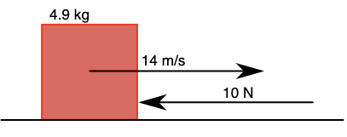
An object of mass 4.9 kg is moving to the right with a constant velocity of 14 m/s when it is acted upon by an unbalanced force of 10 N directed towards the left. Give your answers to two (2) significant figures.
- What is the acceleration given to the mass? (1 mark)
- What is the velocity of the mass at time = 3 s? (1 mark)
Alt text for image: A square object is being depicted moving towards the right on a flat surface. There is a force acting upon the object towards the left. The weight of the square object, the initial velocity of the square object, and the force acting upon the square object, are outlined in the question.
Score: | 2 marks
Solution |  |  |  | Advice required?
Write the solution here including all working out for each step. Indicate the score for each step.
For the first part we have been given the mass in the question, and also the force.

The question states the force is to the left. If we assume the right is the positive direction and the left is the negative direction, then the force applied should be negative.

Taking this into account, we can use Newton's second law to find the acceleration:
𝐹=𝑚𝑎
Rearranged then becomes:
𝑎=𝐹/𝑚
And substituting in the question values:
𝑎 = −10 N/4.9 kg = − 2 m/s²

(1 mark, 0.5 marks if given to incorrect number of significant figures)

For the second part we need to find the velocity of the mass after 3 seconds.
We know there is a force being applied to the object which is causing a negative acceleration. This means the object will be slowing down so we can expect the velocity to be lower than the initial velocity.
We can use the linear motion equation:
𝑣 = 𝑣0+ 𝑎𝑡
Then, substituting the values from the question:
𝑣 = 14 m/s − 2 m/s² × 3 s = 7.9 m/s

(1 mark, 0.5 marks if given to incorrect number of significant figures)
Variables |  | Variable Range | Constants | Variable Conditions
Mass of object |  | 1 – 5 kg in increments of 0.1 kg | N/A | The answer for velocity in part b should be greater than zero.  v1>0  Note: By limiting this answer, the other variables, when randomly generated, will conform to this condition. This will ensure the object will still be moving to the right, and the force will not be enough to stop the object or accelerate it to the left.
Initial velocity |  | 10 – 20 m/s in increments of 1 m/s
Unbalanced force |  | 5 – 20 N in increments of 1 N
Time for part b |  | 2 – 7 s in increments of 0.5 s
Checklist
Detailed steps provided for solution
Detailed marking criteria included
All necessary diagrams have been provided
Authentic variables/constants have been listed and ranges provided
Variable conditions have been described

The end result
When translated into Numbas, the question in the template from the previous page will appear something like this:

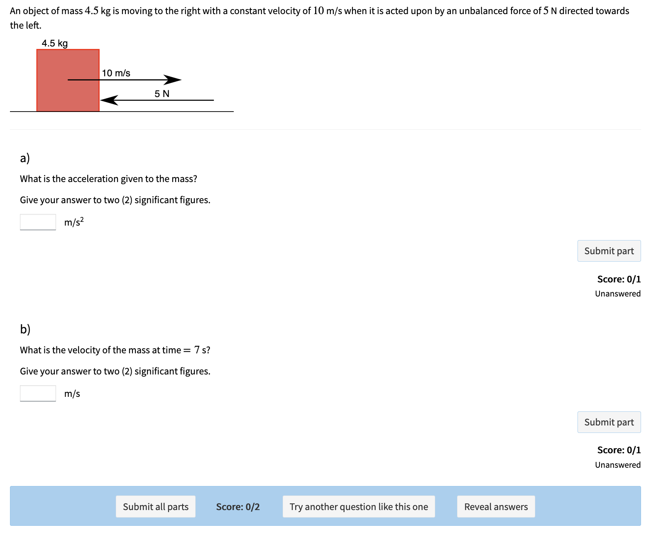

The question variables in this example are different to those written in the original question. If the question is being used in a quiz, the option to r ‘Try another question like this one’ and ‘Reveal answers’ will be removed.
If this question is being presented to learners as a practice quiz, or as a mastery learning exercise, the options can remain. It is important to ensure all instruction to the student is included in the template.
This will appear something like the example on the following page.
The template appears on the final page of this document.
Feel free to copy it as many times as necessary for how many questions you are developing.

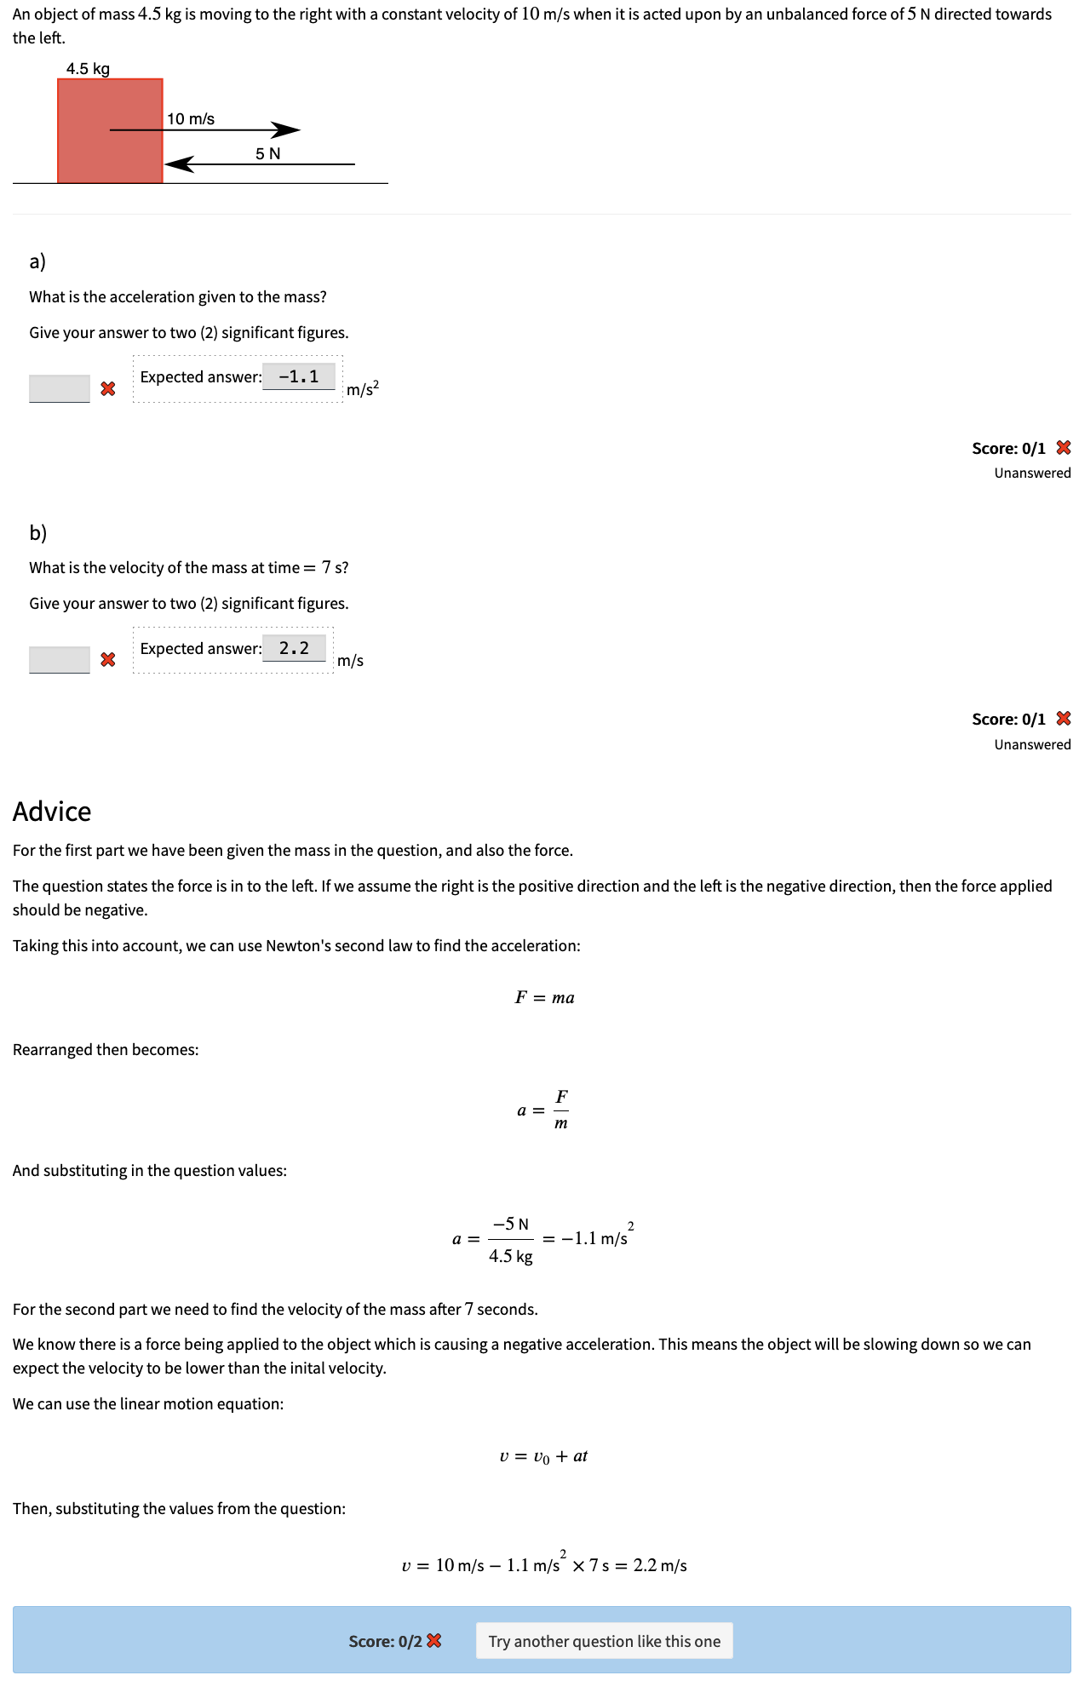
Question
Question Title:
Write your question here.
Score:
Solution |  |  |  | Advice required?
Write the solution here including all working out for each step. Indicate the score for each step.
Variables |  | Variable Range | Constants | Variable Conditions
Checklist
Detailed steps provided for solution
Detailed marking criteria included
All necessary diagrams have been provided
Authentic variables/constants have been listed and ranges provided
Variable conditions have been described

